|  |  |
| --- | --- |
| **Logo_FPT_University_doc** | **MINISTRY OF EDUCATION AND TRAINING** |

|  |
| --- |
| **FPT UNIVERSITY** |
| Capstone Project Document |
| Designing and making  A Lynxmotion A-POD robot controller |
|  |
| |  |  | | --- | --- | | **Hexapod Team** | | | **Group Members** | * PhanAnhDũngCường * Nguyễn Minh Quân | | **Supervisor** | M.Si. TrầnKhánhNinh | | **Ext Supervisor** |  | | **Capstone Project code** | APOD | |
|  |

|  |
| --- |
| - Ho Chi Minh City, 09/2013 - |

# SOFTWARE USER MANUAL (SUM)

## Installation

Following below figures step-by-step for the installation of APOD Controller Software

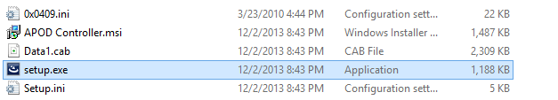

Figure ‑ Run Setup file in delivered package

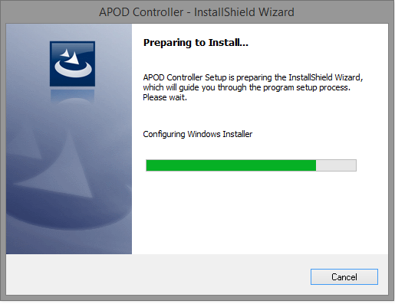

Figure ‑ Waiting for Install Shield to configure Window Installer

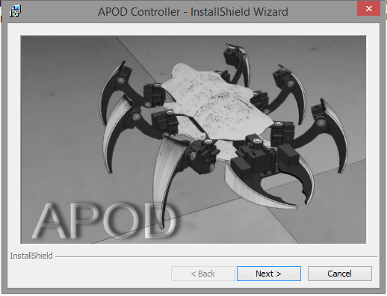

Figure ‑ Click Next on Welcome dialog

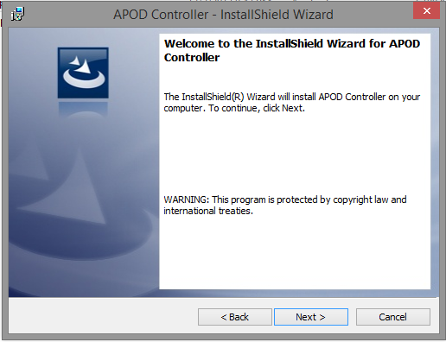

Figure ‑ Click Next to start.

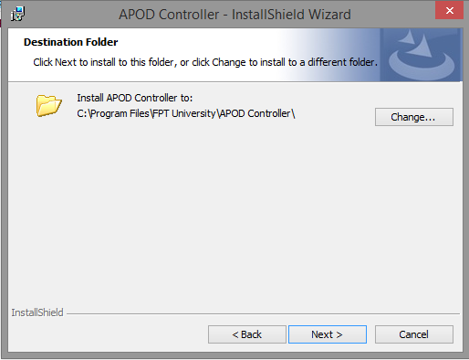

Figure ‑ Choose the location of new program

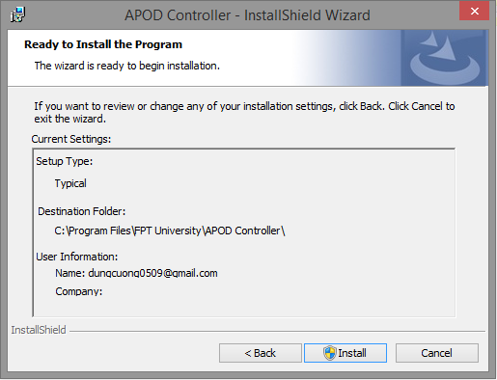

Figure ‑ Re-check setup information

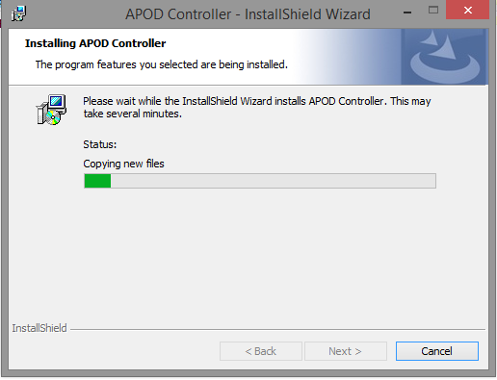

Figure ‑ Waiting for the installation to finish

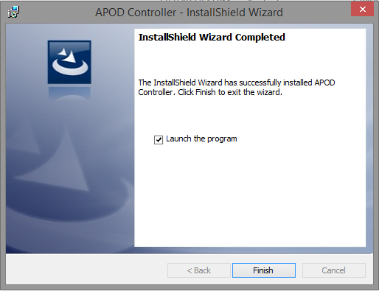

Figure ‑ Finish the installation

## Removal

To remove the program:

* Go to Control Panel -> Programs -> Programs and Features
* In the dialog, Select the “APOD Controller”
* Click Uninstall.

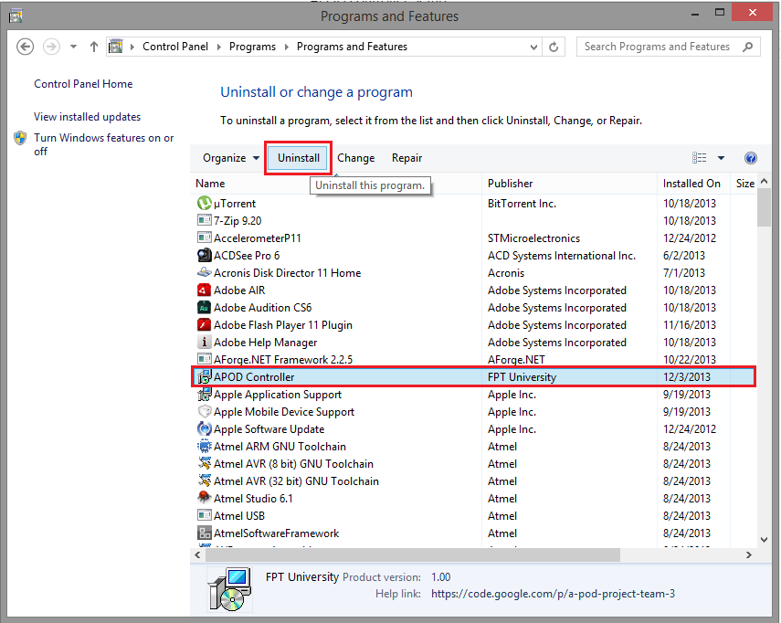

Figure ‑ Remove

## User Guide

### Configuration

#### How to access?

Before using any feature of the software the configuration is needed for setting up connection between user PC and APOD.

To access the configuration Dialog click on menu Tool on the top left corner and select Configuration.

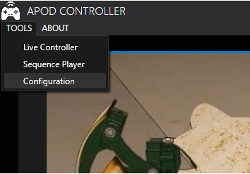

Figure ‑ Menu Configuration

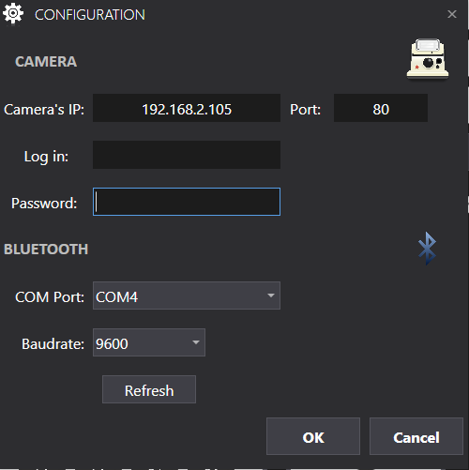

**8**

**7**

**2**

**5**

**6**

**4**

**3**

**1**

Figure ‑ Configuration

|  |  |
| --- | --- |
| Section NO. | Description |
| 1 | This field contain the IP of Camera in your local LAN. Make sure the IP is corrected or the broadcast won’t be able to perform. Access router for the exact IP of Camera. |
| 2 | This is the port number to access camera video stream. This port is fixed from the Camera‘s configuration itself (default is 80). In case camera’s configuration is changed, you must enter the new port here. |
| 3 | Camera log in user name. Check the camera configuration for details |
| 4 | Camera log in password. Check the camera configuration for details |
| 5 | This is the communication COM port (\*) for Bluetooth connection. Select the right port used by Bluetooth or the connection will fail. |
| 6 | COM port baud rate. |
| 7 | Get the new list of available COM port. |
| 8 | Accept or reject the configuration. If you click OK, the connection will be establish and there will be a message if connection fail (wrong configuration) |

Table ‑ Configuration Description

#### How to know Bluetooth Port?

This method describe below is applied for those using Broadcom Bluetooth device driver. Different manufacturers may have different methods to recognize Bluetooth COM port.

On the bottom right corner of your screen. Find the Bluetooth Icon, right click on it and select “Open Settings”

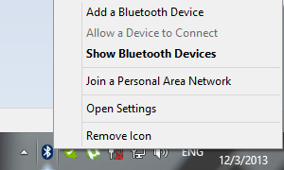

Figure ‑ Open Bluetooth setting

When the Bluetooth Settings dialog appear, switch to the “COM ports” tab.

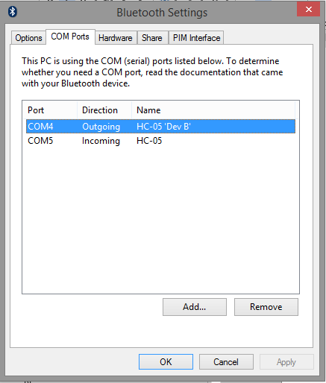

Figure ‑ Bluetooth Settings dialog

As you can see, there a list of COM port using for the Bluetooth, the right port for selecting in the Configuration is the one with “Outgoing” direction. In this case, the right COM port is COM4.

### Live Control

#### How to access?

On the top left menu, click on menu “TOOL” and select “Live Controller”.



Figure ‑ Access Live Controller

#### How to Control?

This is the main view of live control tab.

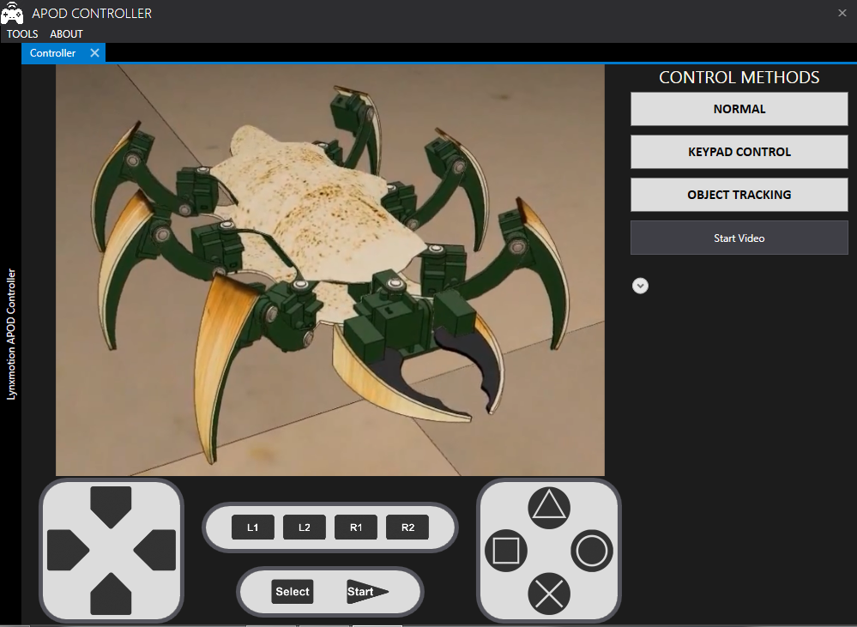

Figure ‑ Live Control Main View

The view of control button is divided into 4 group:

* Navigation: Up (), Down (), Left (), Right ()
* Action: Triangle (), Cross (), Square (), Circle ()
* Bank: L1 (), L2 (), R1 (), R2 ()
* Mode: Select (), Start ()

The mission of each button in group will be shown as below table.

|  |  |  |  |
| --- | --- | --- | --- |
| L1 - L2 (\*) | 00 | 10 | 01 |
| Up | Forward | Toward Front | Head up |
| Down | Backward | Toward Back | Head Down |
| Left | Turn Left | Squeeze Left | Head Left |
| Right | Turn Right | Squeeze Right | Head Right |
| Triangle | Mandibles Grip | -- | -- |
| Cross | Mandibles Release | -- | -- |
| Square | -- | -- | Neck Roll Left |
| Circle | -- | -- | Neck Roll Right |
| R1 | -- | -- | -- |
| R2 | -- | -- | -- |
| Start | Start Up | Body Lift | -- |
| Select | Stop | Body Drop | -- |

Table ‑ Button Command

Notes: (\*) “1” indicate “pressed” and “0” indicate release.

Depend on the selected mode, the input will be mapped to the control buttons.

#### Normal Input

##### Access

To select the Normal input mode, click on the Normal button on the right side. If no configuration was made, you will be prompted to make the configuration (refer to the [Configuration](#_Configuration) section for details).

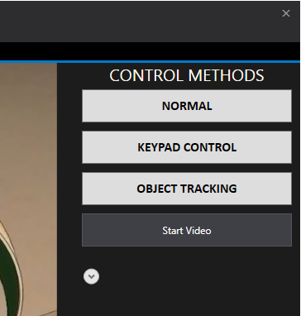

Figure ‑ Select Normal input

##### Control

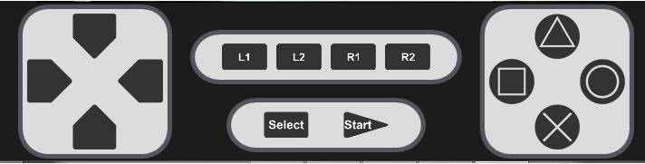

Figure ‑ Control Area using Normal Input

|  |  |  |
| --- | --- | --- |
| Button | Input (keyboard) | Alternate Input |
| Up | w | Click on |
| Down | S | Click on |
| Left | A | Click on |
| Right | D | Click on |
| Triangle | I | Click on |
| Cross | K | Click on |
| Square | J | Click on |
| Circle | L | Click on |
| L1 | Q | Click on |
| L2 | E | Click on |
| R1 | U | Click on |
| R2 | O | Click on |
| Start | H | Click on |
| Select | G | Click on |

Table ‑ Normal Input Control Map

#### Gamepad Input

##### Access

To select the Normal input mode, click on the Normal button on the right side. If no configuration was made, you will be prompted to make the configuration (refer to the [Configuration](#_Configuration) section for details).



Figure ‑ Select Gamepad Input

##### Control

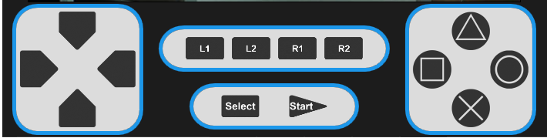

Figure ‑ Control Area using Gamepad Input

|  |  |  |
| --- | --- | --- |
| Button | Input on keypad | Alternate Input |
| Up |  | N/A |
| Down |  | N/A |
| Left |  | N/A |
| Right |  | N/A |
| Triangle | Button 1 or | N/A |
| Cross | Button 3 or | N/A |
| Square | Button 4 or | N/A |
| Circle | Button 2 or | N/A |
| L1 | Button 7 or | N/A |
| L2 | Button 5 or | N/A |
| R1 | Button 8 or | N/A |
| R2 | Button 6 or | N/A |
| Start | Button 10 or | N/A |
| Select | Button 9 or | N/A |

Table ‑ Gamepad Input Control Map

#### Start Camera

To start video streaming, click on the “Start Video” button on the right side. If no configuration was made, you will be prompted to make the configuration (refer to the [Configuration](#_Configuration) section for details).



Figure ‑ Start Video

After starting camera view, the main window will be updated with the view.

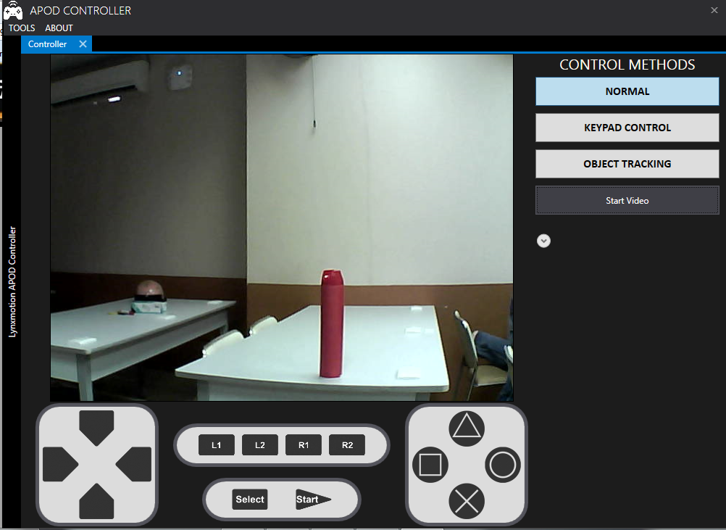

Figure ‑ Camera View

#### Object Tracking

##### Choose Target

The Object Tracking mode will ask you to choose the tracking object for the first time you select.

First step is selected the mode: click on the “Object Tracking” button on the right side.



Figure ‑ Select Object Tracking

If the video stream wasn’t started, you will be prompted an alert. The video stream must be started before using Object Tracking features.

Once you select the mode, a dialog will appear for you to select object. Note that the feature only works for object with solid colors.

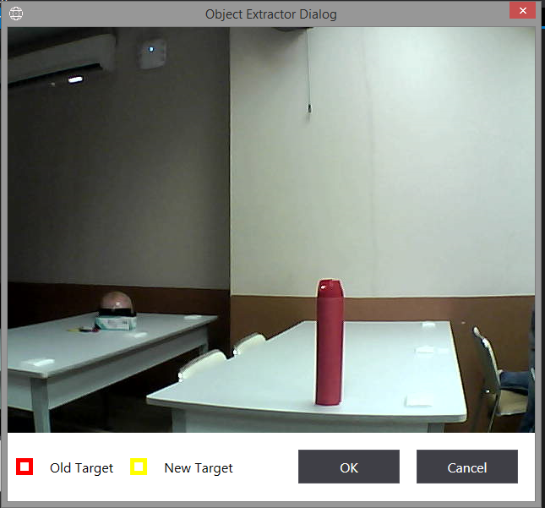

Figure ‑ Object Extractor dialog

Click and drag the mouse on the solid-color area of the target (Tracking template) you want to track.

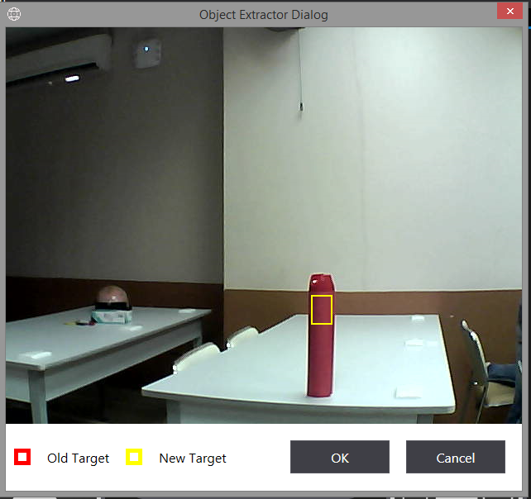

Figure ‑ Select Template

The selected template will be surround by a Yellow rectangle. If you wish to change template, repeat from the “click and drag” step to select new are.

Click “ok” to accept the template.

When return, the camera view will mark the object with a red rectangle as below figure:

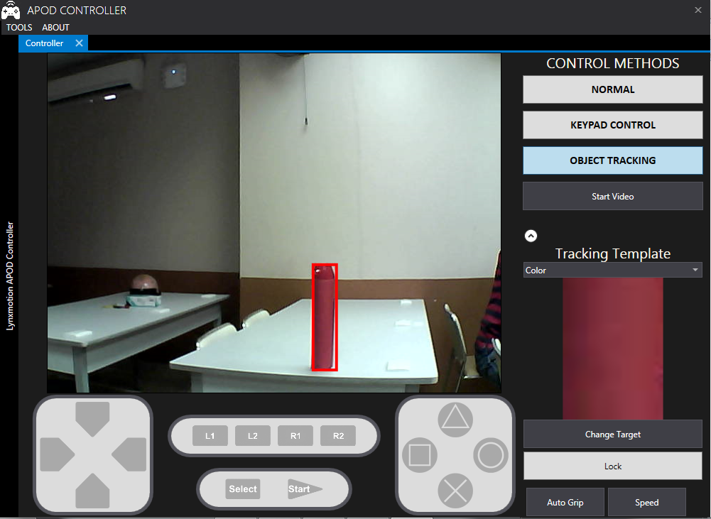

Figure ‑ Camera View with tracking

##### Change Target

If you wish to change tracking target from main view, just click on the “Change Target” button, the Object Extractor dialog will show up again for you to select new tracking template. Refer to the [Choose Target](#_Choose_Target) section for details how to select tracking template.

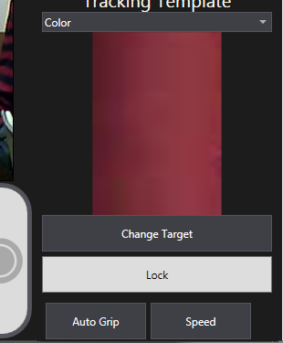

Figure ‑ Change Target button

##### Tracking

By clicking on the “Lock” button, the APOD will actually move toward the target until it reach the target (less than 40 cm). All other moving function will be locked down during the movement.



Figure ‑ Lock Button

##### Auto grip

The “Auto grip” function will make the APOD move forward and grab the object detected in front of the APOD (maximum 40 cm from APOD). The “Auto Grip” move will be trigger after clicking on “Auto Grip” button.



Figure ‑ Auto Grip button

### Sequence Player

#### How to access?

On the top left corner, click on menu “TOOL” and select “Sequence Player”



Figure ‑ Access Sequence player

This will be the main window appearance after selecting “Sequence Player”

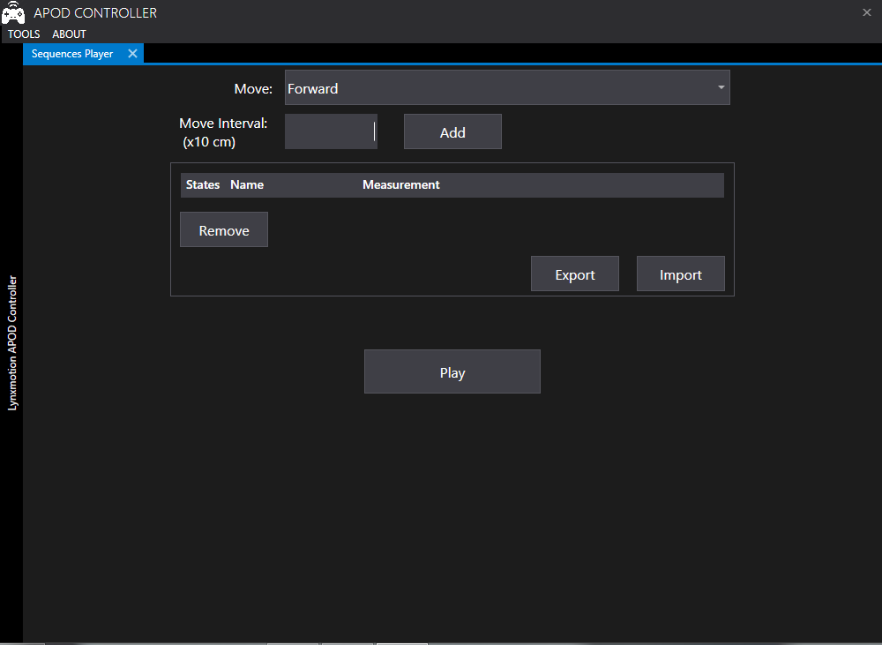

Figure ‑ Sequence Player main appearance

#### Add State

To add a state to a sequence, follow these 2 steps:

* Select move from the “Move” drop down list.

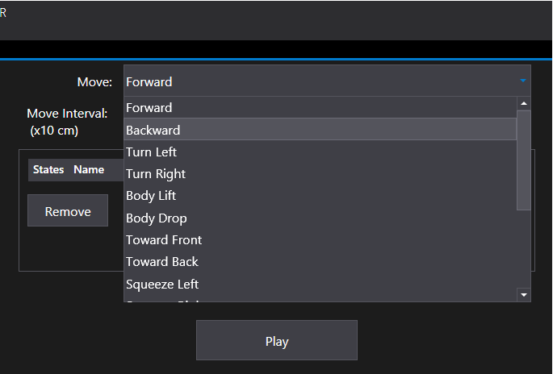

Figure ‑ Select Move

* Enter moving interval in the “Move Interval” fields.
* Click “Add” button

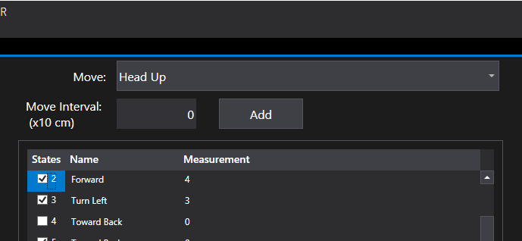

Note that only 4 moves that will require the move interval: Forward, Backward, Turn Left, Turn Right. When selecting any move out of those 4s, the “Move Interval” field will be auto set to “0”.

#### Remove States

Form the existing sequence, to remove states, follow these steps:

* Select States to be removed by the check box on the left.

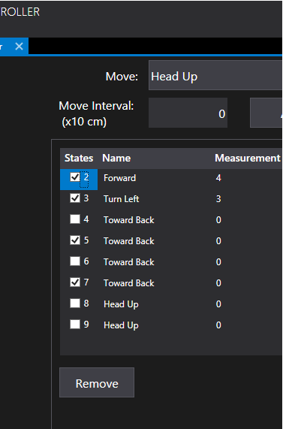

Figure ‑ Select States to remove

* Click on “Remove” button. Those states that was selected will be removed from sequence.

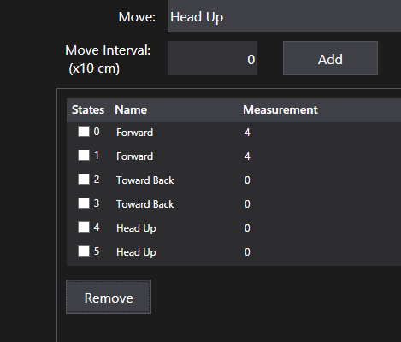

Figure ‑ After Removal

#### Import States

A sequence can be saved as a .xml file for later use (see [Export States](#_Export_States)). To read a sequence from file, follow these steps:

* Click on “Import” button

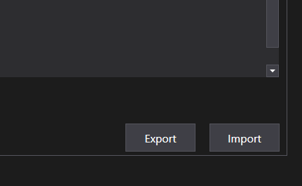

Figure ‑ Import Button

* Browse to the location of sequence file.

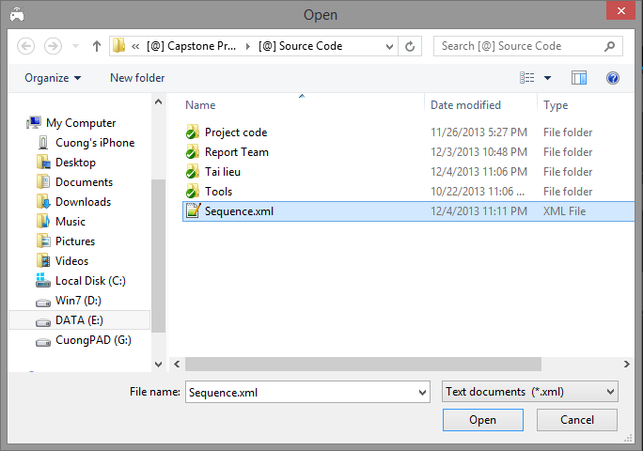

Figure ‑ Browse file to import

* Select file and click Open.

The current sequence will be replaced by file’s content.

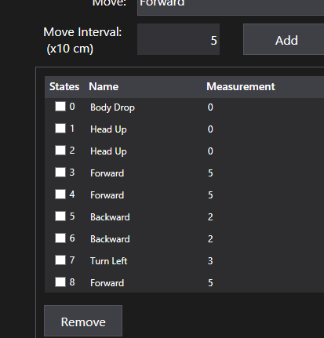

Figure ‑ After import

#### Export States

To export current sequence to file, follow these steps:

* Click on “Export” button



Figure ‑ Export button

* Browse to the location to save file

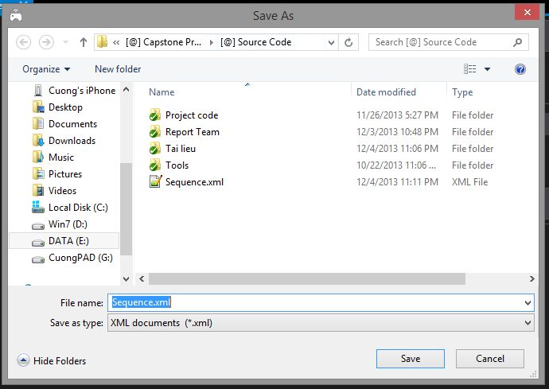

Figure ‑ Browse to save file

* Enter file name and click Save.

Current sequence states will be save to a text file (.xml) as below figure.

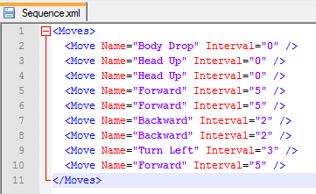

Figure ‑ Sequence file

#### Execution

To execute the sequence, just click on the “Play” button, the APOD will move by the pre-set sequence.

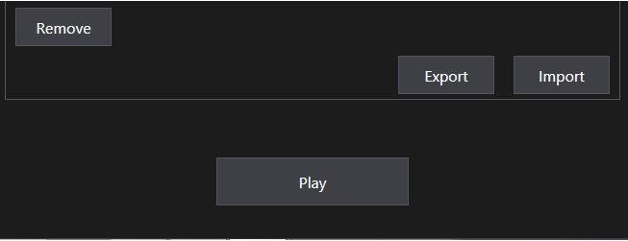

Figure ‑ Play button

Note that while the sequence is being played, all others movement control will be locked down until sequences is finish.